Geosynchronous Satellite

**Overview**

Geosynchronous satellites are satellites in a geosynchronous orbit—a geocentric orbit that has the same orbital period as the rotational period of the Earth. The orbit has a semi-major axis of 42,164 kilometers or 26,200 miles. In a more general case, when the orbit has some inclination or eccentricity, the satellite appears to describe a more or less distorted figure-eight in the sky, and essentially rests above the same spot of the Earth's surface once per sidereal day.

**Geosynchronous and geostationary orbits**

The geosynchronous orbit is also sometimes described as a geostationary orbit. Although there is some difference between the two orbits, they are also related. Both orbits are about 35,786 kilometers above Earth's surface, which puts it in a high Earth orbit category. At any inclination, a geosynchronous orbit synchronizes with the rotation of the Earth.

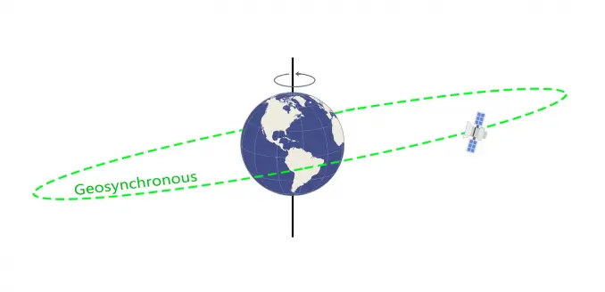

An example of a geosynchronous orbit.

While a geosynchronous orbit can have any inclination, geostationary orbits lie on the same plane as the equator; this is the key difference between these two types of orbits.

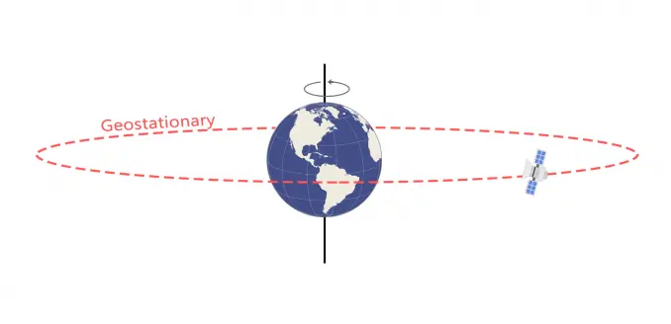

An example of a geostationary orbit, a sub-category of geosynchronous orbits.

Weather monitoring satellites like GOES are in geostationary orbits because they have a constant view of the same area. In a high Earth orbit, these satellites can also be useful for search and rescue beacons.

### **Advantages of GEO or Geosynchronous Earth Orbit**

Following are the **advantages of GEO orbit**:

➨As it is at greater height, it covers larger geographical area. Hence only 3 satellites are required to cover the entire Earth.

➨Satellites are visible for 24 hours continuously from single fixed location on the Earth.

➨It is ideal for broadcasting and multi-point distribution applications.

➨Ground station tracking is not required as it is continuously visible from earth all the time from fixed location.

➨Inter-satellite handoff is not needed.

➨Less number of satellites are needed to cover the entire earth. Total three satellites are sufficient for the job.

➨Almost there is no doppler shift and hence less complex receivers can be used for the satellite communication.

### **Disadvantages of GEO or Geostationary Earth Orbit**

Following are the **disadvantages of GEO orbit**:

➨The signal requires considerable time to travel from Earth to satellite and vice versa. The signal travel delay is about 120ms in one direction. The distance of 35786 Km gives 120 ms latency with 3x108 m/sec speed of the signal. Hence it is not suitable for point to point applications requiring time critical applications such as real time voice, video etc.

➨Since GEO orbit is located above the equator, it is difficult to broadcast near the polar region.

➨Due to longer transmission distance, the received signal is very weak. This requires better LNA (Low Noise Amplifier) and also advanced signal processing algorithms in the satellite modem. This increases cost of the ground station equipments.

➨It provides poor coverage at higher latitude places usually greater than 77 degrees.

**GEO satellite maintenance**

Due to the increased collision risk, and the relative importance of these satellites for communication and navigation systems, geosynchronous orbit maintenance has become an increasingly important issue. These satellites maneuver frequently and require the ability to detect unknown maneuvers for target satellites and to allow those satellites to recover an accurate orbit. Studies have been used to determine if angles from ground-based optical tracking to detect maneuvers and recover orbits can be used. One such tool, developed by Analytical Graphics Inc, uses sequential estimation software that uses a parametric study of maneuver size and time required to detect a maneuver. The company has also suggested various methods to recover the orbit after such maneuvers have been detected. This work is important towards developing more automatic methods of detecting maneuvers for a large population of active geosynchronous satellites.

**Use cases for geosynchronous orbits**

Due to the near stationary position of geostationary satellites, they have been used for global communications, television broadcasting, weather forecasting, and defense and intelligence applications.

Communications

For communications, a large geostationary satellite can provide a large amount of capacity across up to a third of the Earth's surface, and a network can cover the Earth with only three satellites. Further, these satellites can use multiple bands to allow a single satellite to layer capacities.

Government communications

For government communications, this can ensure that a network is capable of delivering greater capacity as required and that governments can achieve availability and reliability when moving to a new situation or location at short notice. However, one complication with newer communication systems and GEO satellites is the latency introduced through the distance of the orbit from the terrestrial stations. With GEO satellites, there can be latency up to 0.25 seconds between signal origination and reception. In part, this has driven the popularity of low Earth orbit satellites for emerging communications systems for their lack of latency.

Internet-based communications

However, with low Earth orbit satellites, a signal has to be swapped every seven minutes, and this switching is considered a possible point of failure or interruption with a signal, while a GEO satellite remains "fixed" and does not suffer from this possible point of friction.

Telecommunications

Geosynchronous satellites have long been a major medium for linking together terrestrial telecommunications networks. Satellite systems share the frequency spectrum with other satellite systems, and in most frequency bands with terrestrial radio systems. The most useful orbit for communication satellites is the geostationary orbit, and the signal channels between satellite and control earth stations required for these functions are carried by radio subsystems. Margin of power is provided in addition to ensure that channel performance targets are reached. Communication satellites are designed to relay several signals simultaneously. And satellite communications are capable of long-distance communications and can be operated with mobile terrestrial terminals.

Broadcasting

Broadcasting has been a use case for geosynchronous satellites for almost as long as satellites have been in the geosynchronous orbit. These satellites have been used for direct-broadcast satellite television, in which the satellite sent transmission directly to a home. Previous to the popularity of direct-broadcast television, these satellites were used to transmit signals for conventional broadcasting.

As broadcasting has changed and the use of satellites in broadcasting has continued, hybrid satellite systems have been used to offer radio access systems capable of providing both terrestrial and satellite connectivity. Practical examples of the existing hybrid systems, such as digital video broadcasting-satellite services to handheld devices, have been used. The main focus in these types of satellite systems is in solving spectrum challenges between the terrestrial and satellite components.

Navigation

One of the most well-known use cases of GEO satellites is the satellite-based navigation system, which is used to localize a radio receiving terminal, also referred to as the global positioning system (GPS). All GPS satellites share the same frequency bands, making use of the code division multiple access (CDMA) technique.

Weather forecasting

Geosynchronous satellites are also used for weather forecasting. These satellite systems have unique characteristics and are capable of producing different products. These geostationary satellites spin at the same rate of the Earth and are capable of constantly focusing on the same area. This enables the satellite to take pictures of the Earth at the same location every thirty minutes.